**Chapter 3**

**Derivatives**

**3.5 Derivatives of Trigonometric Functions**

**Section Exercises**

**For the following exercises, find  for the given functions.**

175. 

Answer: 

177. 

Answer: 

179. 

Answer: 

181. 

Answer: 

183. 

Answer: 

**For the following exercises, find the equation of the tangent line to each of the given functions at the indicated values of . Then use a calculator to graph both the function and the tangent line to ensure the equation for the tangent line is correct.**

185. **[T]** 

Answer: 

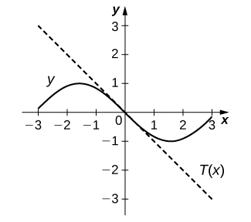

187. **[T]** 

Answer: 

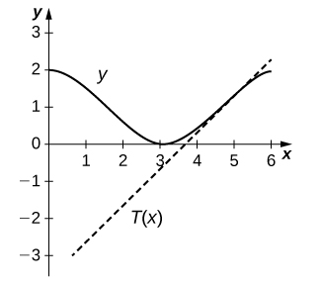

189. **[T]**  

Answer: 

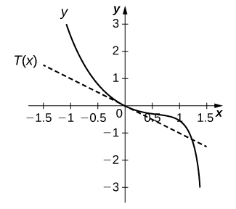

**For the following exercises, find  for the given functions.**

191. 

Answer: 

193. 

Answer: 

195. 

Answer:

197. Find all  values on the graph of  where the tangent line is horizontal.

Answer: 

199. Let  Determine the points on the graph of for  where the tangent line(s) is (are) parallel to the line 

Answer: 

201. Let the position of a swinging pendulum in simple harmonic motion be given by. Find the constants  and  such that when the velocity is 3 cm/s,  and 

Answer: 

203. The number of hamburgers sold at a fast-food restaurant in Pasadena, California, is given by  where  is the number of hamburgers sold and  represents the number of hours after the restaurant opened at 11 a.m. until 11 p.m., when the store closes. Find  and determine the intervals where the number of burgers being sold is increasing.

Answer: increasing on  and 

**For the following exercises, use the quotient rule to derive the given equations.**

205. 

Answer: This is a proof; therefore, no answer is provided.

207. 

Answer: This is a proof; therefore, no answer is provided

**For the following exercises, find the requested higher-order derivative for the given functions.**

209.  of 

Answer:

211.  of 

Answer:

213.  of 

Answer:

This file is copyright 2016, Rice University. All Rights Reserved.